PROJECT REPORT TEMPLATE

1. INTRODUCTION: -

1.1 Overview:-

**An Applicant Tracking System or ATS is an all-in-one human resource software that automates the hiring process, helps HR teams efficiently manage every part of recruitment (from job posting to onboarding), and solves recruiters’ challenges and pain points.**

**1.2 Purpose: -**

* **Weeds out unqualified candidates and recommends the best fit for a position based on the parameters set by HR. Only those on the shortlist are moved to the next stage of the hiring process.**
* **Automates time-consuming administrative tasks such as manually screening applicants, reading resumes, scheduling interviews, and sending notifications and emails to job candidates and employees.**
* **Stores job candidate information like resumes, cover letters, references, and other recruitment and hiring data that HR teams can easily access and organize.**

**2. Problem Definition and Design Thinking: -**

**2.1 Empathy Map: -**

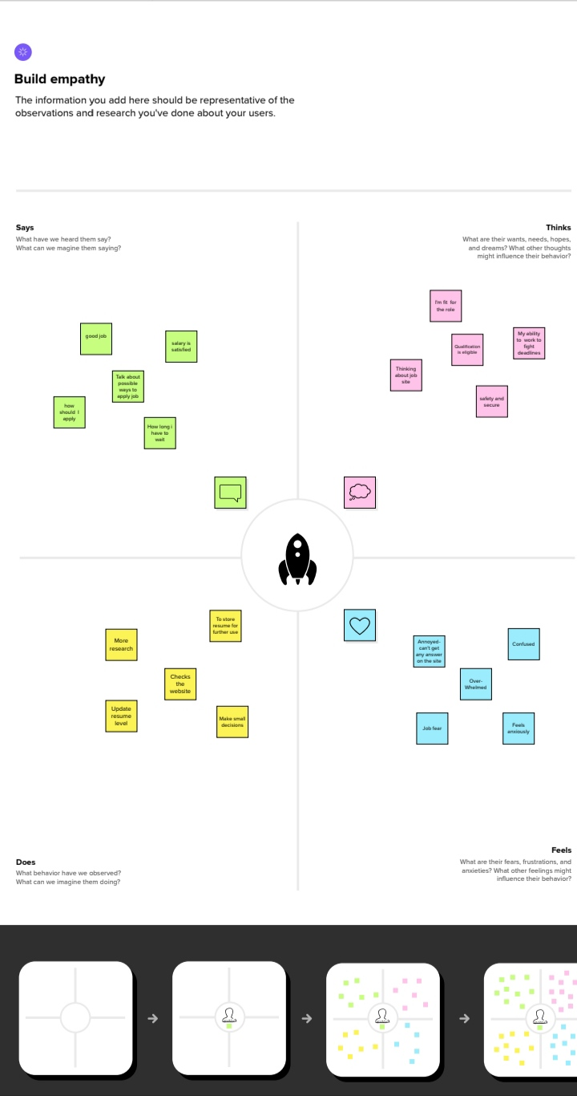

**2.2 Ideation and Brainstorming map Screenshot: -**

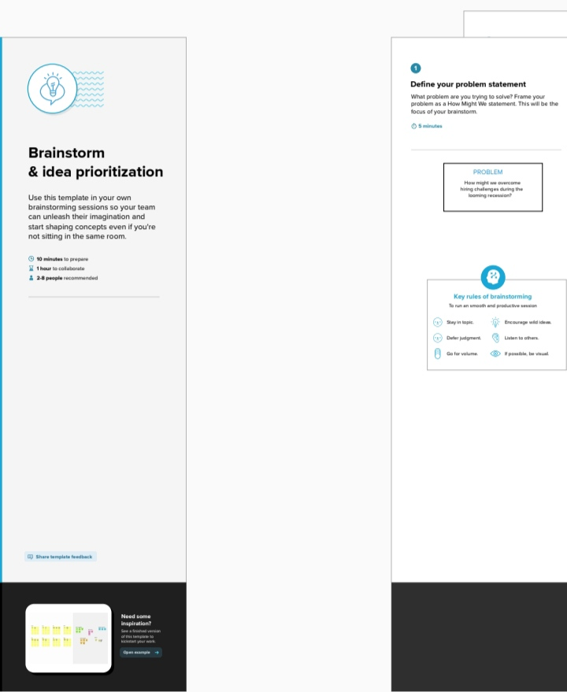

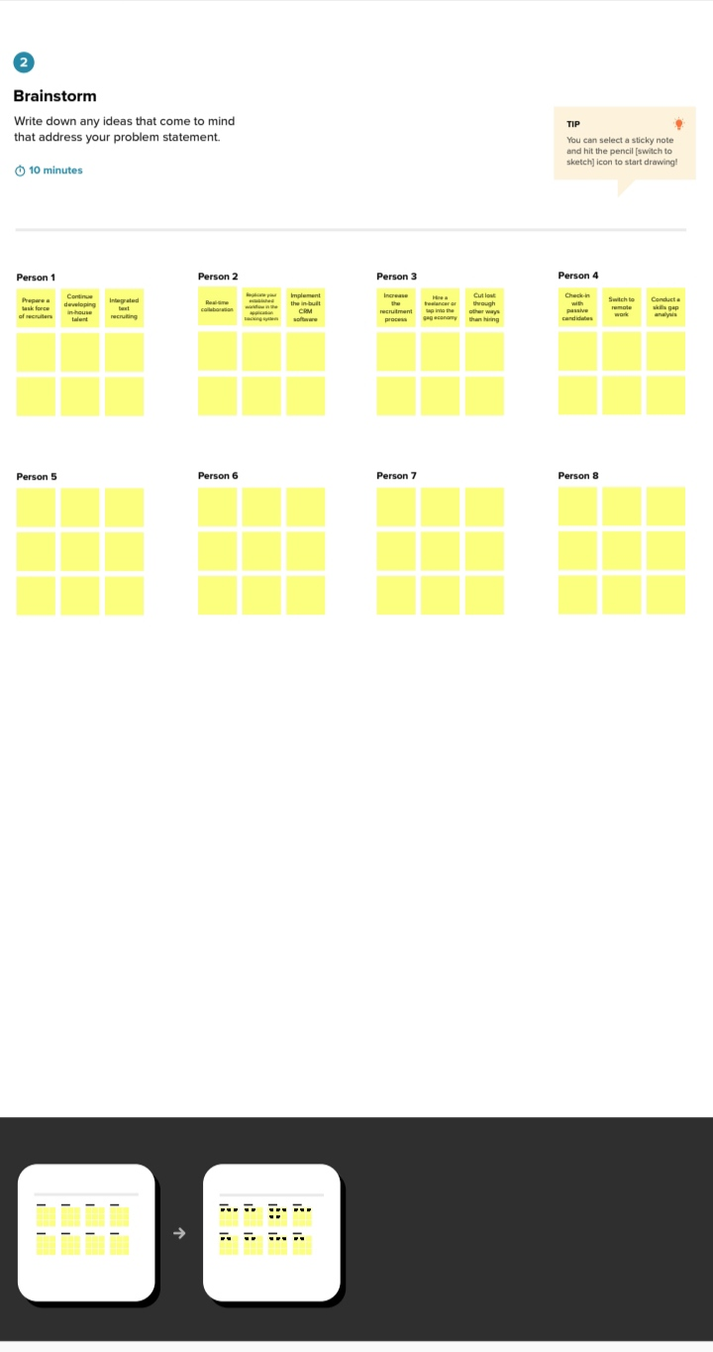

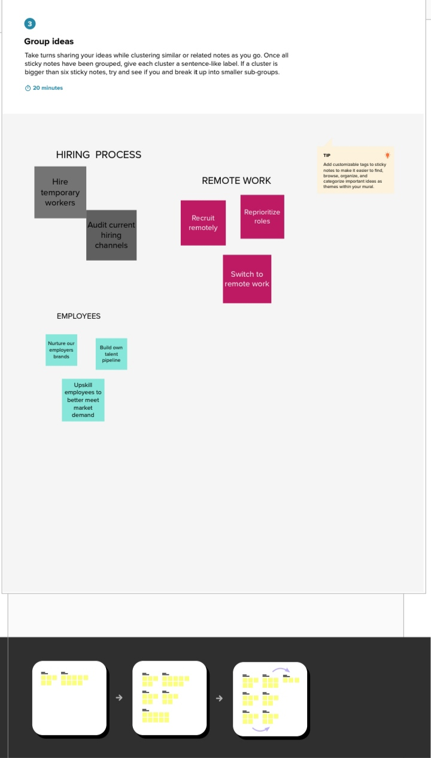



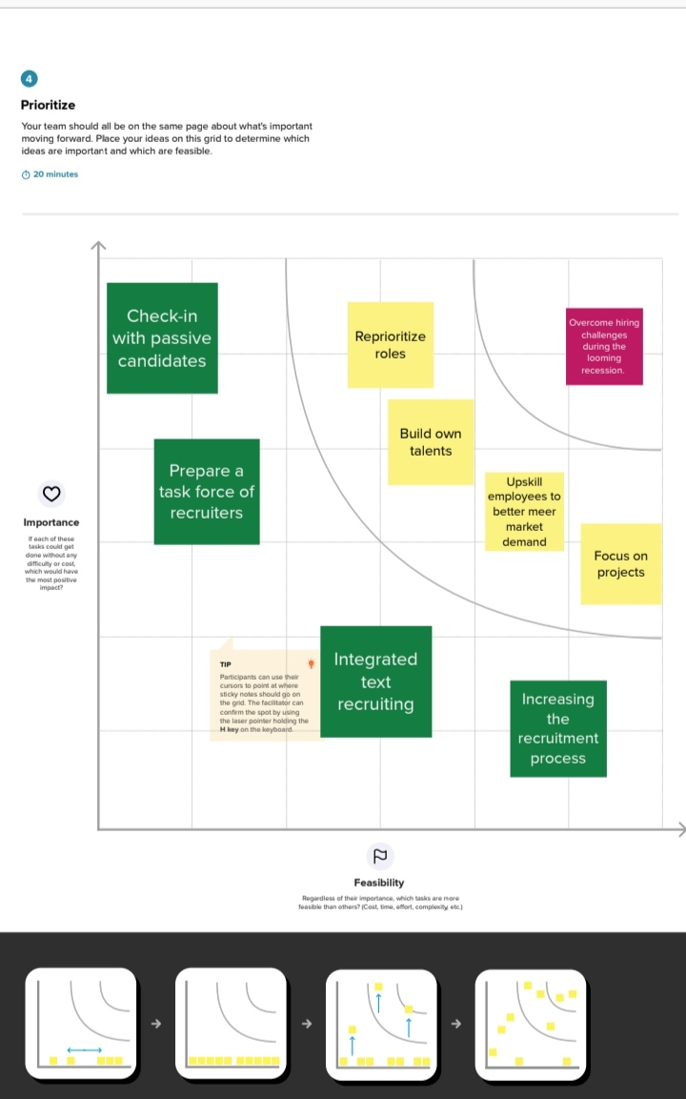

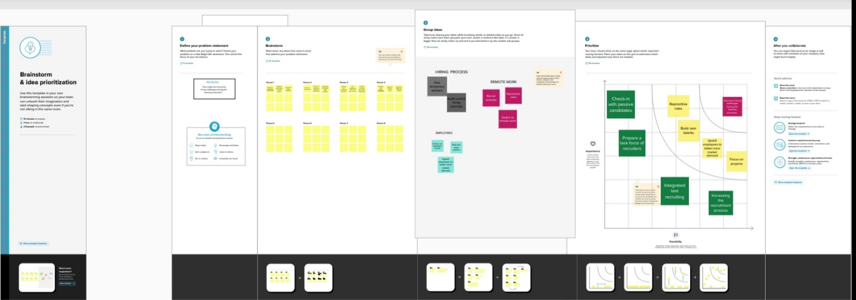

**3. RESULT:-**

|  |  |
| --- | --- |
| **Object Name** | **Field in the Object** |
| **Object -1** | **Field Label: Recruiter**  **Data type: Auto number** |
| **Object-2** | **Field Label: Object Tab**  **Data type: Tab** |

**Activity and Screenshot:-**

**Salesforce**

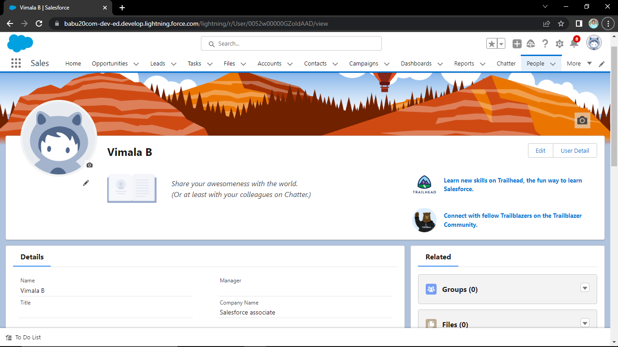

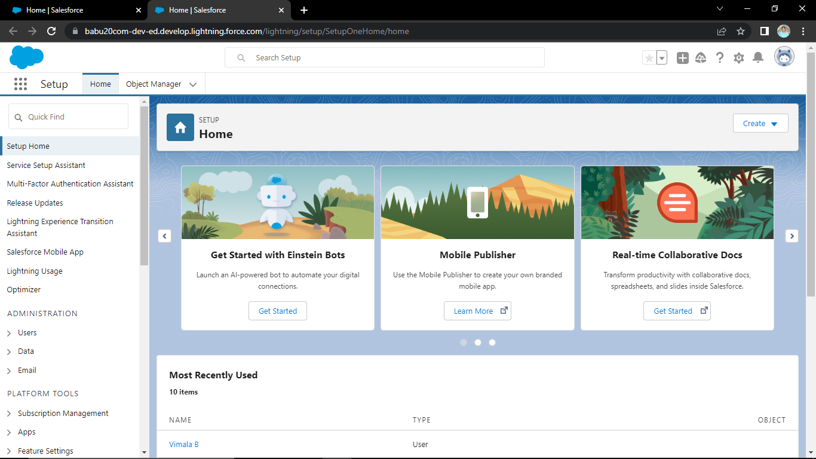

**Object**

**Create a custom object for recruiter:**

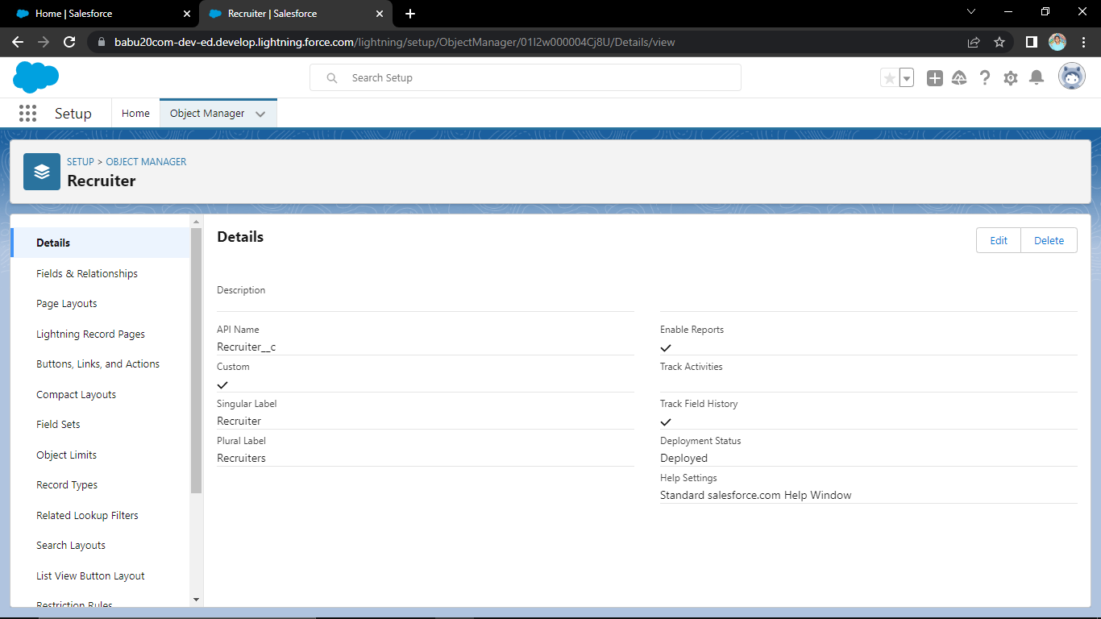

**Create a Jobs, Candidate, Job application object and tab:**

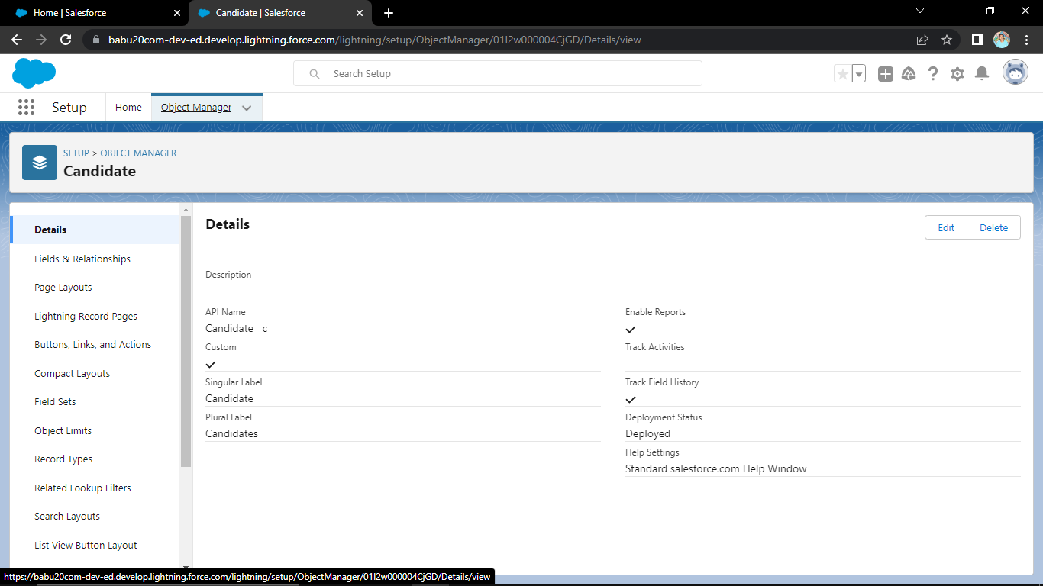**Fields**

**Create the custom object fields:**

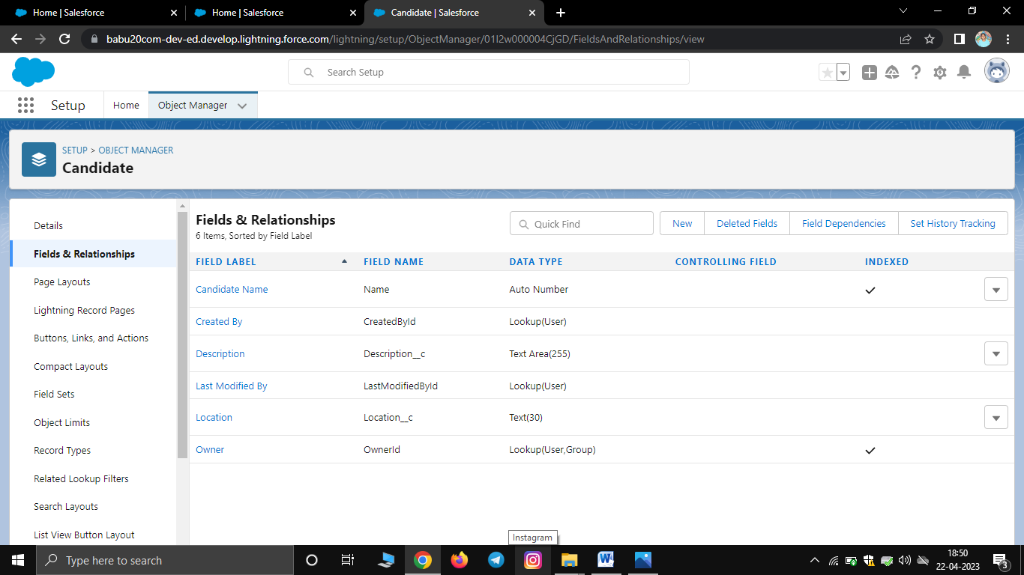

**Tab:**

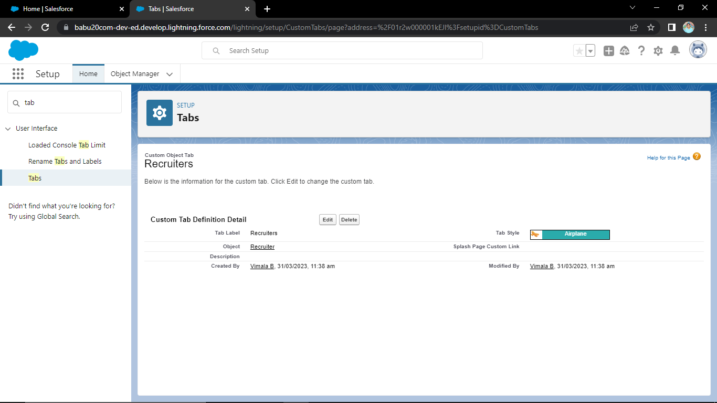

**Profile**

**Create a Custom profile:**

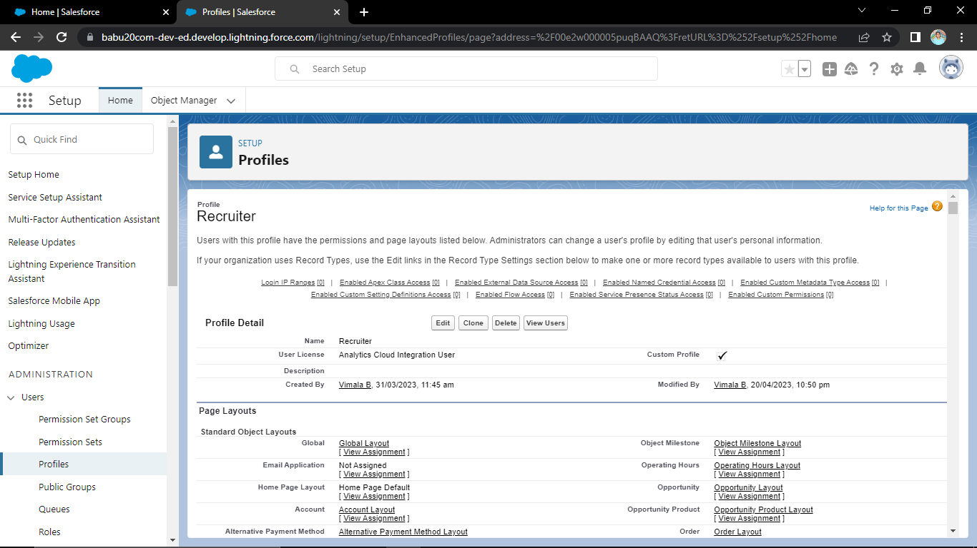

**Create a profile with the profile name as ”Sales Manager”**

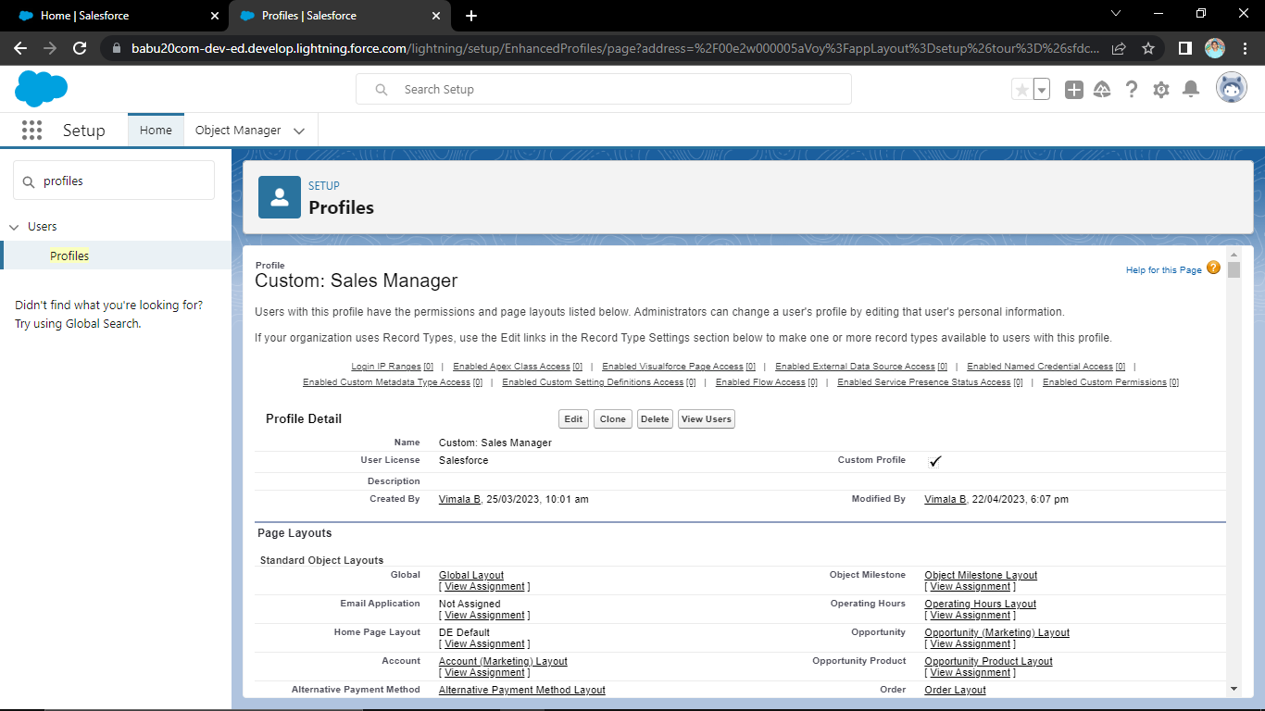

**Users**

**To create user:**

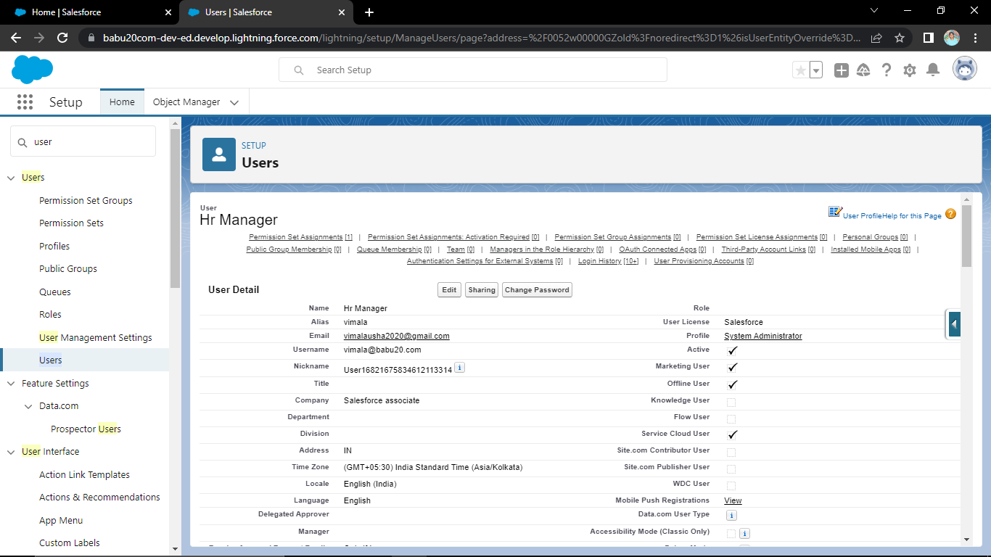

**Create a user with a username as ”Ganesh Gelli”**

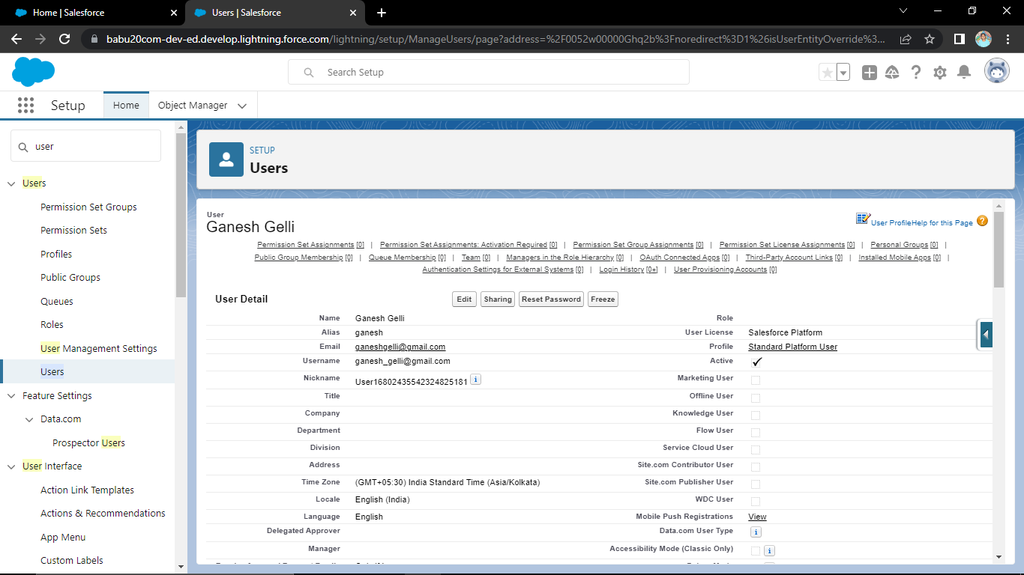

**Sharing rules**

**Create a sharing rule**

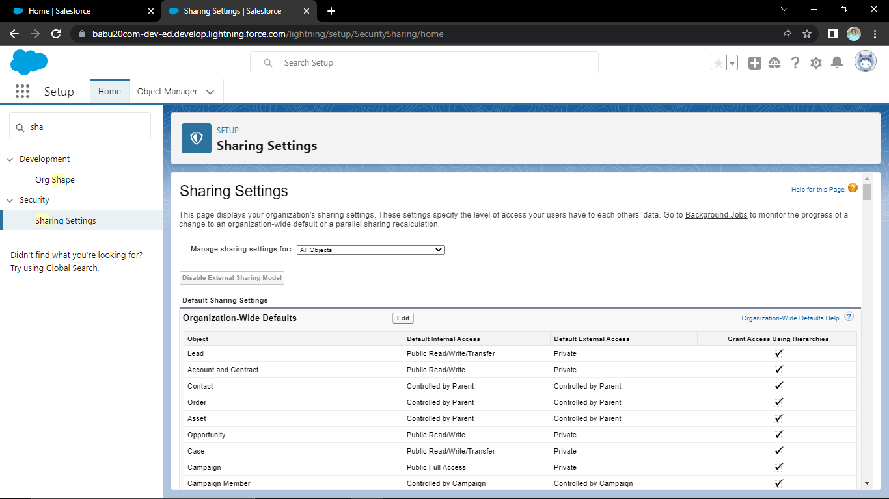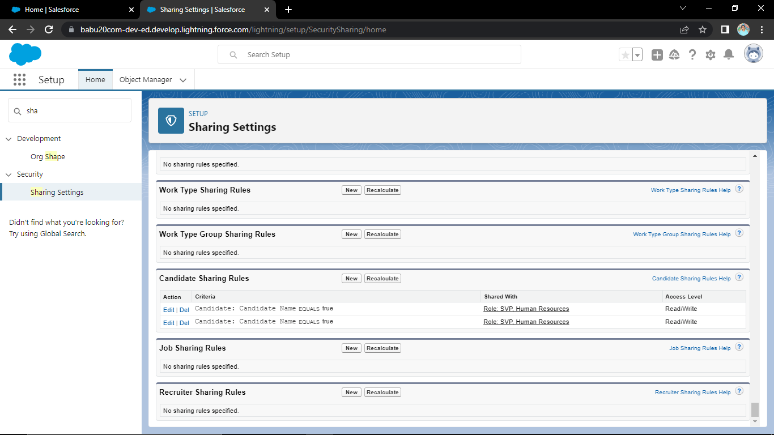

**Report**

**Create a report and using the objects, jobs, candidates and applications :**

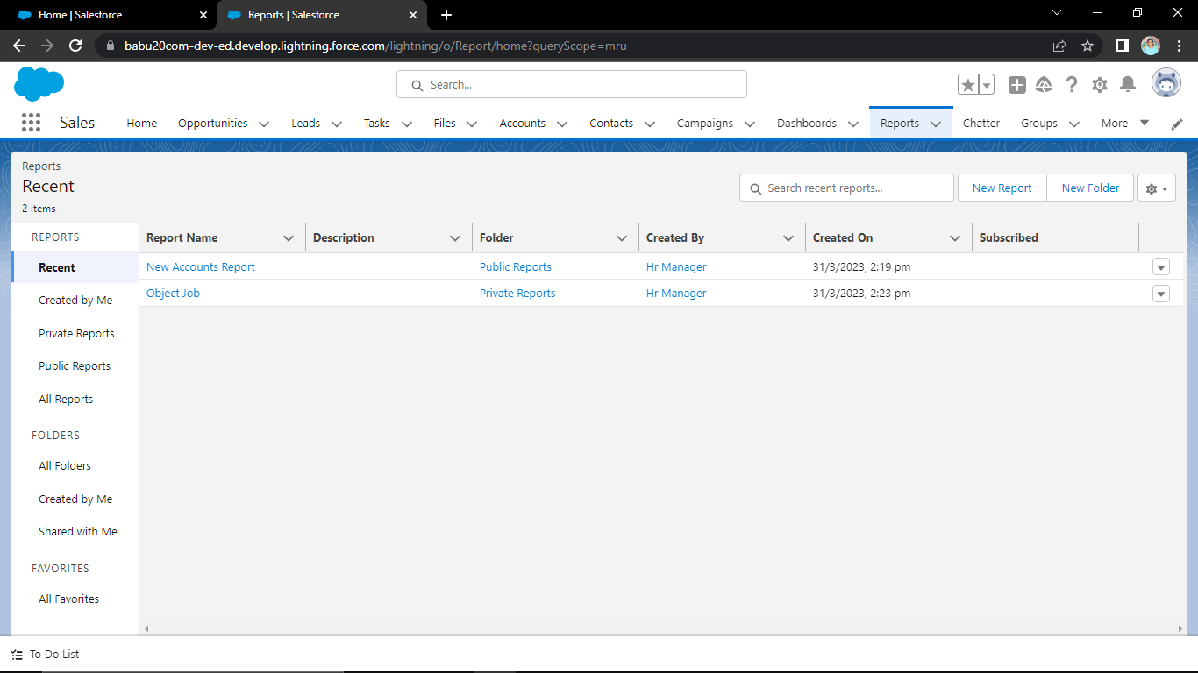

**4. Trailhead Profile Public URL:**

**Team Lead -** [**https://trailblazer.me/id/vimalababu**](https://trailblazer.me/id/vimalababu)

**Team Member 1-** [**https://trailblazer.me/id/fyos5c64**](https://trailblazer.me/id/fyos5c64)

**Team Member 2-** [**https://trailblazer.me/id/thuvr**](https://trailblazer.me/id/thuvr)

**Team Member 3-** [**https://trailblazer.me/id/yuvaj3**](https://trailblazer.me/id/yuvaj3)

**5. ADVANTAGES and DISADVANTAGES:-**

1. **Saves Time for Value Added Work:**

**The topmost advantage of an automated Applicant Tracking System is that it saves a lot of time compared to conventional application processing and hiring procedures.An average of 75-88 % of resumes received are not qualified for the job. By eliminating the manual posting and listing on job boards, then filtering out the irrelevant applications, this whole process is done in a matter of seconds rather than spending hours on it.**

1. **Flexible System for Both Employer & the Agency:-**

**Recruitment agencies obviously gain a lot by using an ATS. It is a blessing even for the client as listings, interview feedback, and all other co-ordinations can seamlessly be handled online. Imagine the efficiency if you do not have to deal with loads of emails, excel sheets,and remember notes or appointments that are now handled on a single platform!**

1. **Better Overview of Applications:-**

**Keeping all the documents in your recruiting databases you all the necessary details you need in one location .You can easily switch between apps, compare candidates, change candidate status, and select and scan candidates without leaving the system .This removes the risk of a submission being missed or trapped on a team member’s desk. Few ATS’ have just a simple Kanban view to make things easier. You can view a sample of the Kanban view here.**

1. **Easy Job Posting:-**

**Applicant Tracking Software lets you upload your job openings on several platforms with a single click. You do not need to set it up manually to log in to individual accounts from each social platform and post the job. You also do not need to track each social media platform and the results generated from each post individually. The software will gather the analytics from each platform and collate them together for you. An ATS like Recruit CRM allows you to integrate a careers site page on your website. You can then use this website to collect online applications. You can also save some serious cash in recruitment marketing. These job boards will automatically provide you with plenty of traffic for your openings.**

**APPLICATION:**

**• Saves Time for Value Added Work.**

**• Flexible System for Both Employer & the Agency.**

**• Better Overview of Applications.**

**• Easy Job Posting.**

**• Improved Cost-per-Hire.**

**• Improved Quality of Hire.**

**• Improved Inter-Departmental Communication.**

**• Faster & Better Decisions.**

**CONCLUTION:**

**The Applicant Tracking System for recruiters is a very effective hiring solution that most of the successful recruiters utilize. Because without it, there is a good chance that your process of moving applicants through different stages can become very difficult.**

**FUTURE SCOPE:**

**Due to the massive adoption of government agencies and companies, ATS global market size is expected to reach $3.2 billion by 2026 which means it is here to stay.As the world of recruitment is**

**changing rapidly, HR professionals are using technological innovations and AI to better improve the ATS. This allows recruiters to do more through the ATS and its deep integrations especially with the rise of remote hiring.**